Training Project Requirements Document
Online Exam System -- Web
Last Updated: Sep 02, 2017

Executive Summary
This document specifies the requirements of the training project to be completed by myself. I'm completely responsible for finishing every deliverable is described in the “Project Deliverables” section.
Document History
Date | Author | Summary of Change | Note
2017/11/02 | Leif Liu | Initialized version.  Refined the detail requirement points: Role name, Default password.  Refined UI.  Added MySQL – Connector – Java.jar for MySQL.  Refined according to new UI design.
Table of Content

1 Project Deliverables 4
2 Project Requirements 5
3 Optional Requirements 8
4 Prerequisite Tools 8
5 Required Design Choices 9

Project Deliverables
The project is considered complete when the following deliverables have been fulfilled.

Project Plan
Functional Specification
Use Case
DB design
Code Complete
Source Code
Functional Build
Release Notes
Unit Test
Unit Test Code
Bug List & Review Issue List

Note:
All code must follow the Java Coding Convention.
You can refer to UI design materials to facilitate requirement understanding.

Project Requirements
Online Exam web system provides user management, question management and exam management functions. The user with SysAdmin role can manage all users including create/edit/delete user. The user with ContentAdmin role can manage questions and create exam. Each user can access this web system to edit his personal profile.

2.1 User Management
Requirement points for this function are as below:
1. Only users with SysAdmin role have permission to manage user.
2. Create user
- Required fields: User name, Password, Gender, Role type, Telephone number, Email address
- Option fields: Chinese Name
- Role Types: SysAdmin, ContentAdmin, Student, Teacher
- Default Password: The default password(123456) for each user can be configured in configuration file or database
3. Edit user
4. Delete user
5. View users list
- Be able to view all users
- Be able to view the user list by pagination
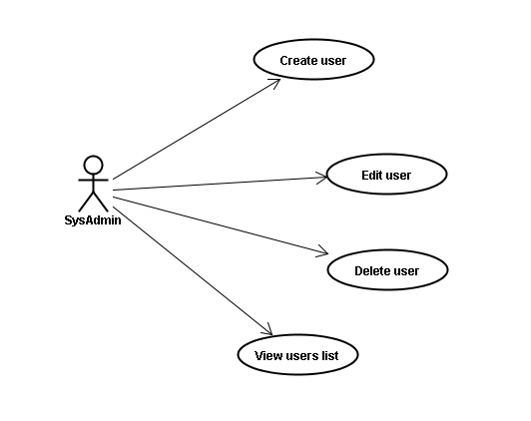

2.2 Question Management
Requirement points for this function are as below:
1. Only users with ContentAdmin role have permission to manage questions.
2. Create question
- Question type is a single choice with 4 optional answers (A、B、C、D)
3. Edit question
4. Delete question
5. View questions list
- Be able to view all questions
- Be able to view the questions list by pagination
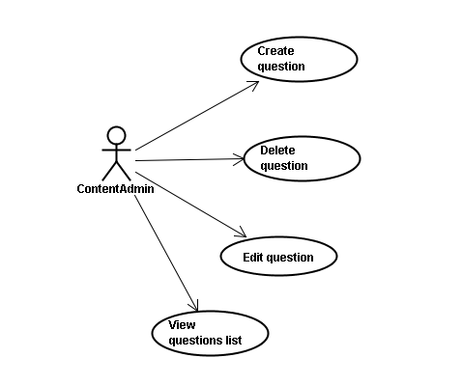
- Be able to fuzzy search questions by keyword in question title field

2.3 Exam Management
Requirement points for this function are as below:
1. Only users with ContentAdmin role have permission to create exam.
2. Create exam
- Required fields: Exam name, Single question score, Question quantity, Exam duration, Total Score, Pass Criteria
- Option fields: Exam description
- Generate exam by picking up questions randomly from already existed questions in this system
- The question order is fixed once the exam is generated. Winform client will display the questions according to the question order when generate exam
- If question is not enough in system, pop-up a warning message. But still can save exam as draft
3. View exams list
- Be able to view all exams
- Be able to view the exams list by pagination
- Be able to fuzzy search exams by exam name field or exam description field
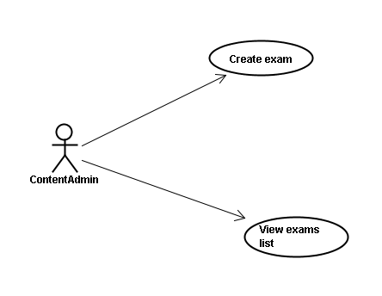
- Be able to refresh the exams list order by total score field

2.4 Other functions
For all users (include student and teacher), below requirement points are also required:
1. Login&Logout
2. Edit user profile

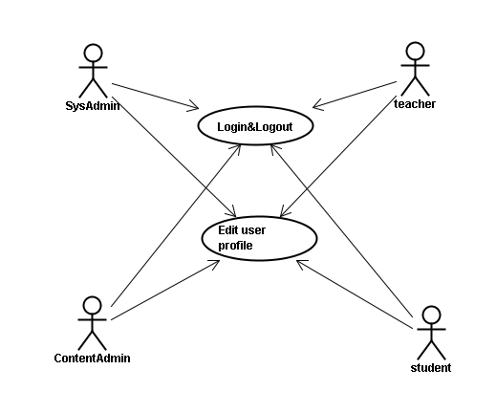
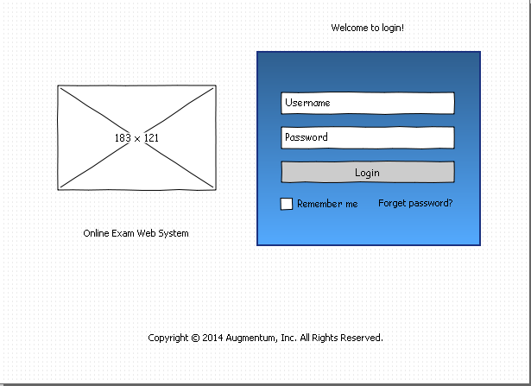
Optional Requirements
1. Full separate frontend and backend code. Convert all data retrieval and storage as JSON APIs, use pure front code (HTML, CSS and JS) to render the pages.
2. System can switch between Chinese and English. The default language can be configured by SysAdmin.
3. Search user by user name or Chinese name or telephone number.
4. Create question with picture or other type of attachment like doc or xls.
5. Mail function. A congratulation mail will be sent when he passes one exam.
6. Report function. The score and user of each exam will be logged and use a report to show this exam history.

Prerequisite Tools
JDK 1.7
Tomcat 7.0.54
MySQL 5.1.53
Log4J 1.2.16
JUnit 4.10
MySQL – Connector – Java – 5.1.18.jar

Required Design Choices
Logging
All logging of system information will be done with Log4J.

Unit Tests
All unit tests will be completed with JUnit test framework.

Internationalization (I18N)
String literals that can be localized later (visible labels, error messages, informational messages, etc.) must be in Java resource bundle.

SpringMVC Framework 3.0.x
Use IOC/AOP to complete the business logic

Mybatis 3.2.x
Implement persistent layer with ORM.

